Assignment 6: CST8912 – Cloud Solution Architecture
Graded Lab Activity #6
Introduction: Azure Private Link, a secure connectivity option for private network access to Azure services, is the main emphasis of this lab. By guaranteeing that data traffic stays inside the Azure virtual network (VNet) and is not exposed to the public internet, Azure Private Link streamlines network architecture. By providing a private, direct connection, Private Link enables customers to safely access Azure PaaS services, Microsoft partner services, or even custom services developed by their company.
Objective: Enabling you to construct, configure, and test an Azure Private Link and Private Endpoint is the aim of this experiment. By the conclusion, you will know how to safely link Azure services to a virtual network, satisfying regulatory requirements, lowering the danger of internet exposure, and guaranteeing confidential communication between your business's bespoke Azure services and clients.
Step 1: Create a Virtual network and Bastion Host
- In the portal, we searched for and select Virtual networks. On the Virtual networks page, we selected + Create.
On the Basics tab of Create virtual network, we entered the following information:

Setting | Value
Subscription | Azure for students
Resource Group | CST8912demo
Name | 8912-vnet1
Region | Canada Central

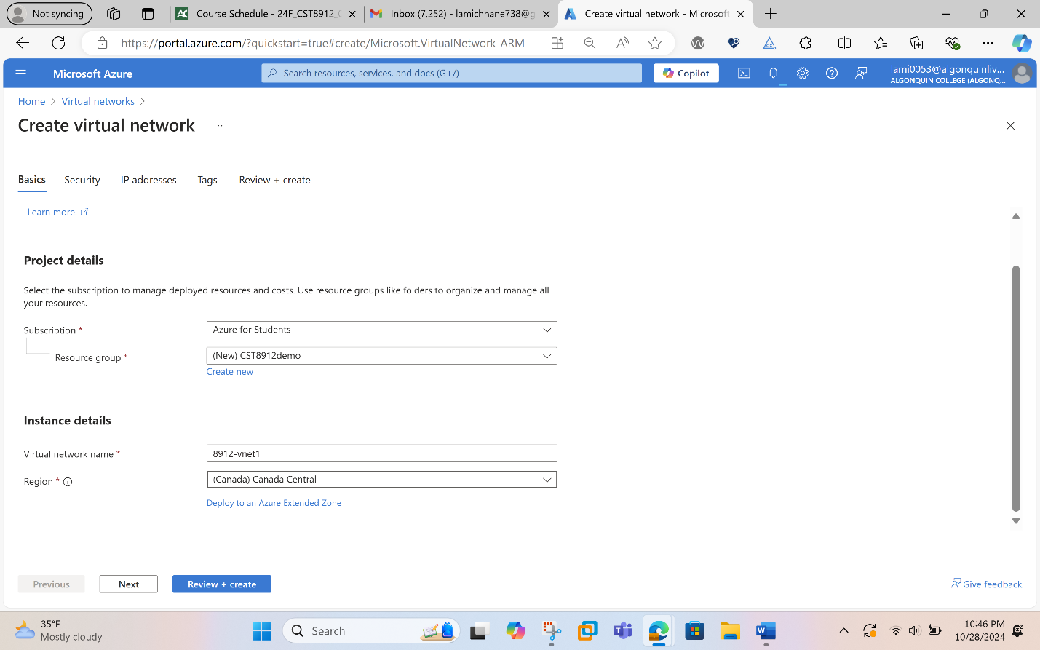
- The we select Next to proceed to the Security tab. Select Enable Bastion in the Azure Bastion section of the Security tab. Enter or select the following information in Azure Bastion:
Setting | Value
Azure Bastion host name | Enter Bastion8912
Azure Bastion public IP address | Select Create a public IP address.  Enter public-ip in Name.  Select OK.
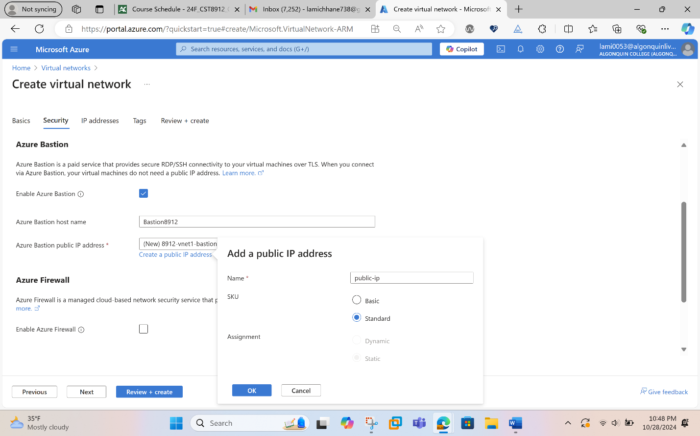
- Select Next to proceed to the IP Addresses tab. In the address space box in Subnets, select the default subnet.In Edit subnet, enter or select the following information:
Setting | Value
Subnet template | Leave the default Default.
Name | Subnet-1-8912
IPv4 address range | Leave 10.0.0.0/16.
Starting address | Leave the default of 10.0.0.0.
Subnet size | Leave the default of /24(256 addresses).
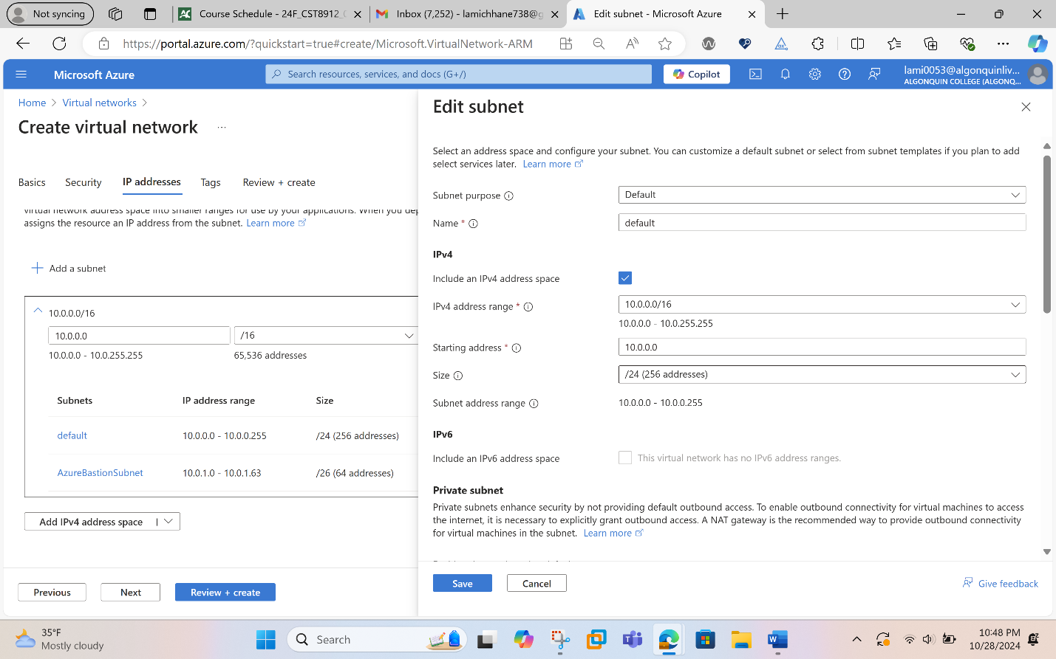
Next step is to select save and the create and review when the validation passes.

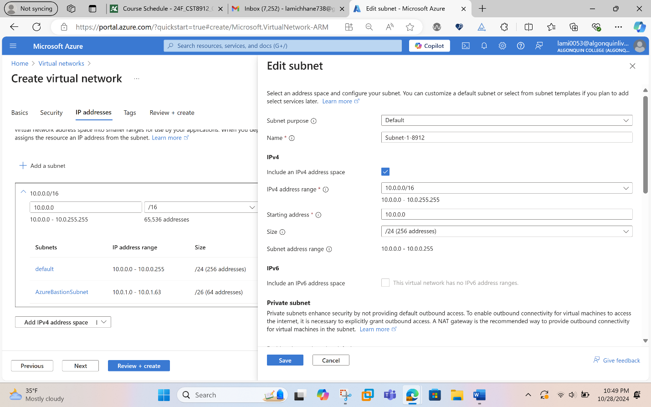
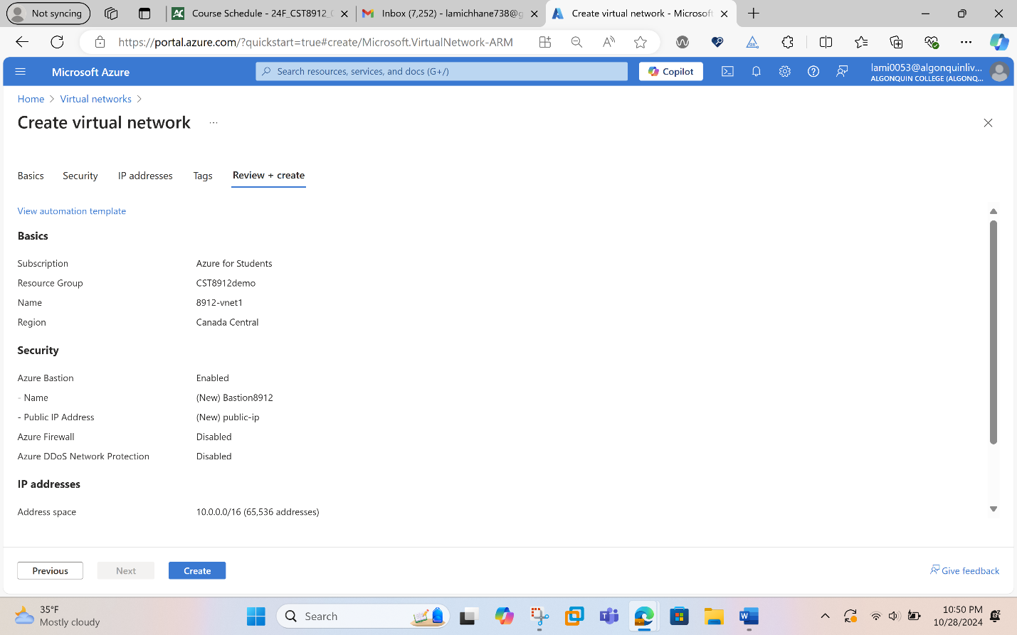

Step 2: Creation of a Storage Account
In the search box at the top of the portal, we entered Storage account. Selected Storage accounts in the search results and then selected + Create. Then in the Basics tab to Create a storage account we entered or select the following information:
Setting | Value
Subscription | Azure for students
Resource Group | CST8912demo
Storage Account Name | Storage1-8912
Location | Canada Central
Performance | Standard
Redundancy | Local Redundant Storage (LRS)
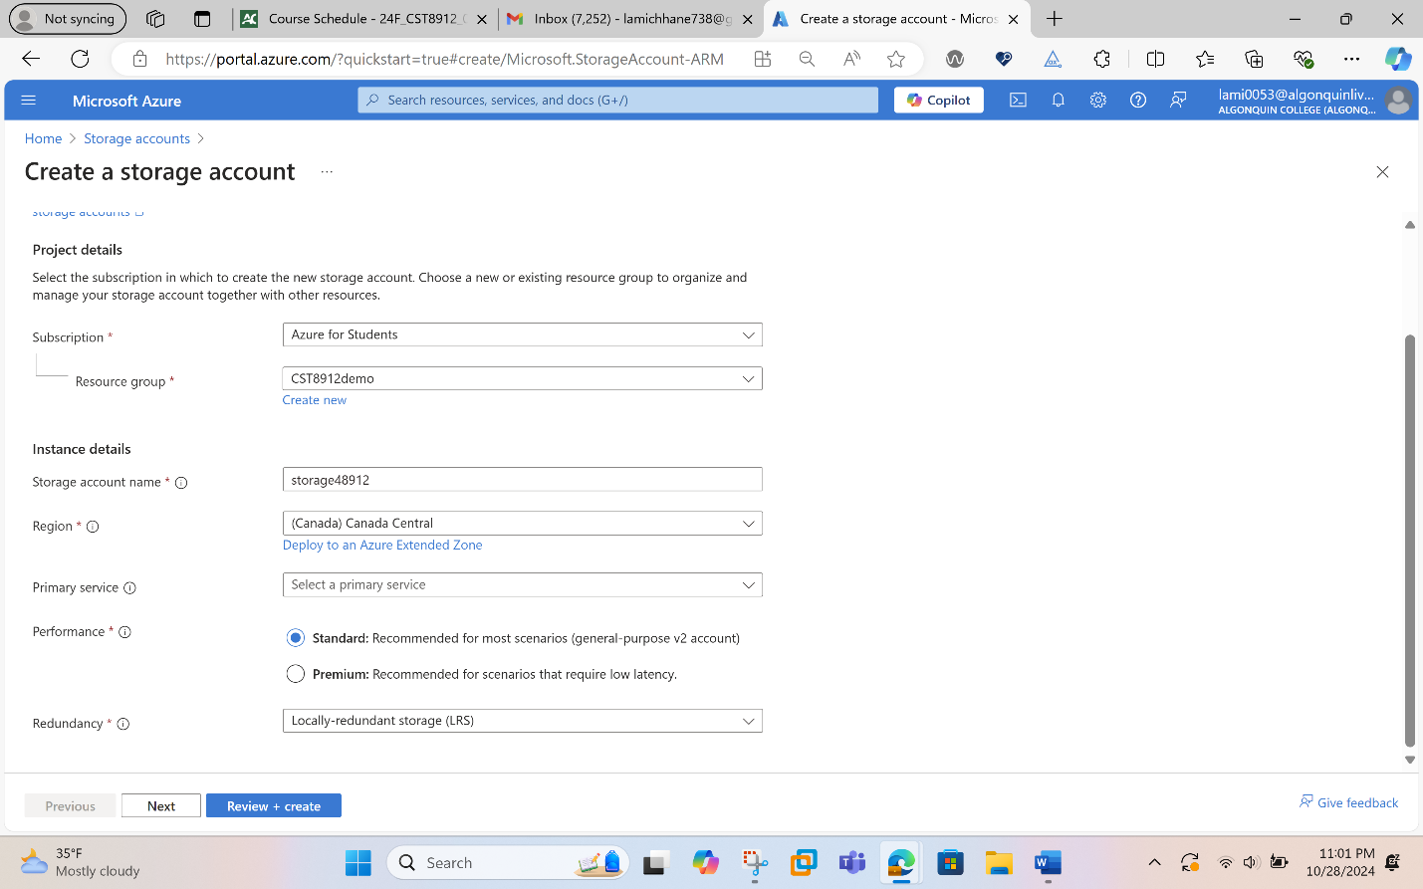
Finally select review and select create.
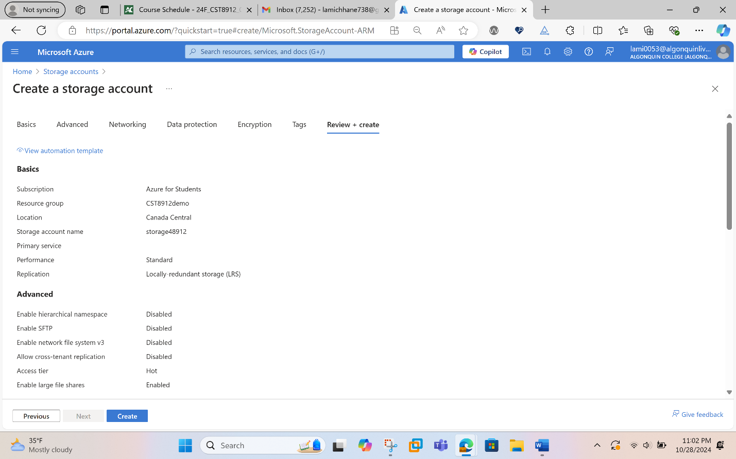
The overview page of storage looks like this:
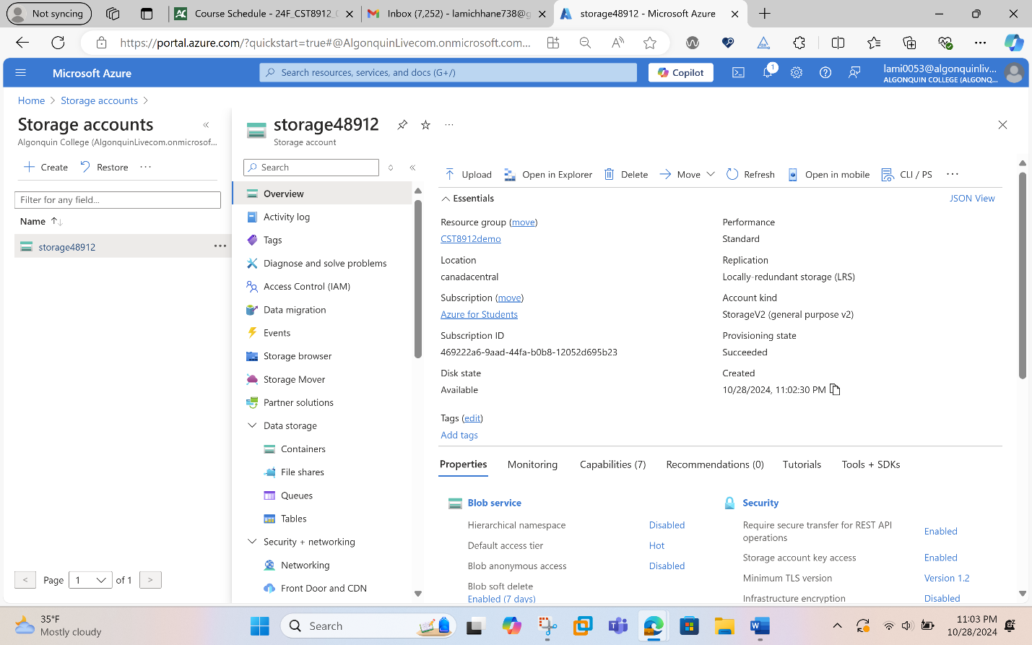
Step 3: Disable public access to storage account
In the search box at the top of the portal, enter Storage account. Select Storage accounts in the search results. Select storage1 or the name of your existing storage account. In Security + networking, select Networking. In the Firewalls and Virtual Networks tab in Public network access, select Disabled and then finally select Save.
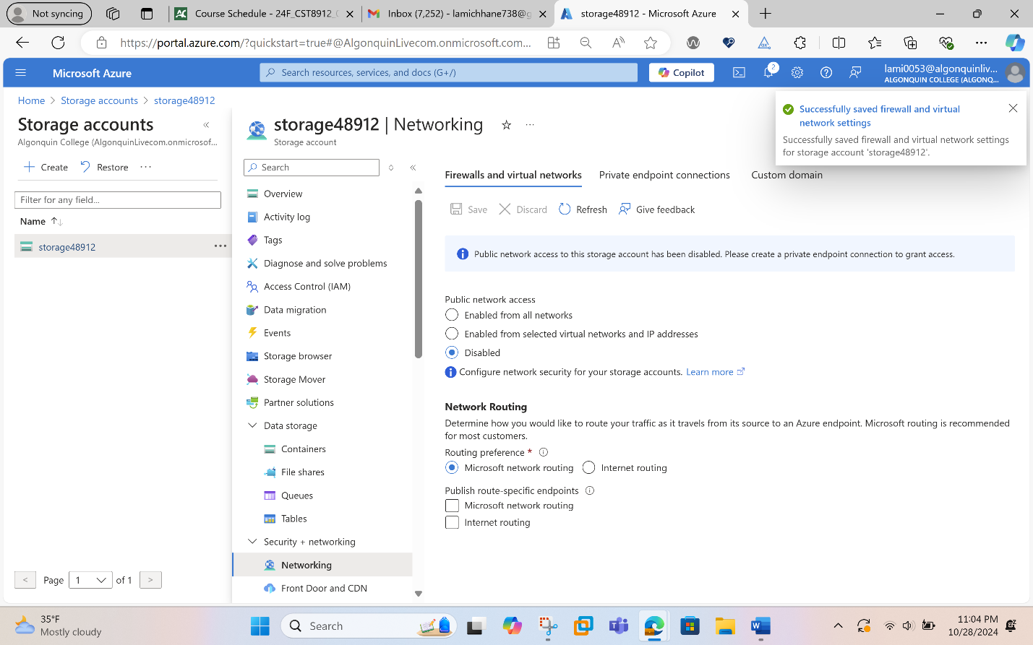Step 4: Create private endpoint
In the search box at the top of the portal, enter Private endpoint. Select Private endpoints.
Select + Create in Private endpoints and in the Basics tab of Create a private endpoint, enter or select the following information.
Setting | Value
Subscription | Azure for students
Resource Group | CST8912demo
Name | Privateendpoint-8912
Network Interface Name | Leave the default of private-endpoint-nic.
Region | Canada Central

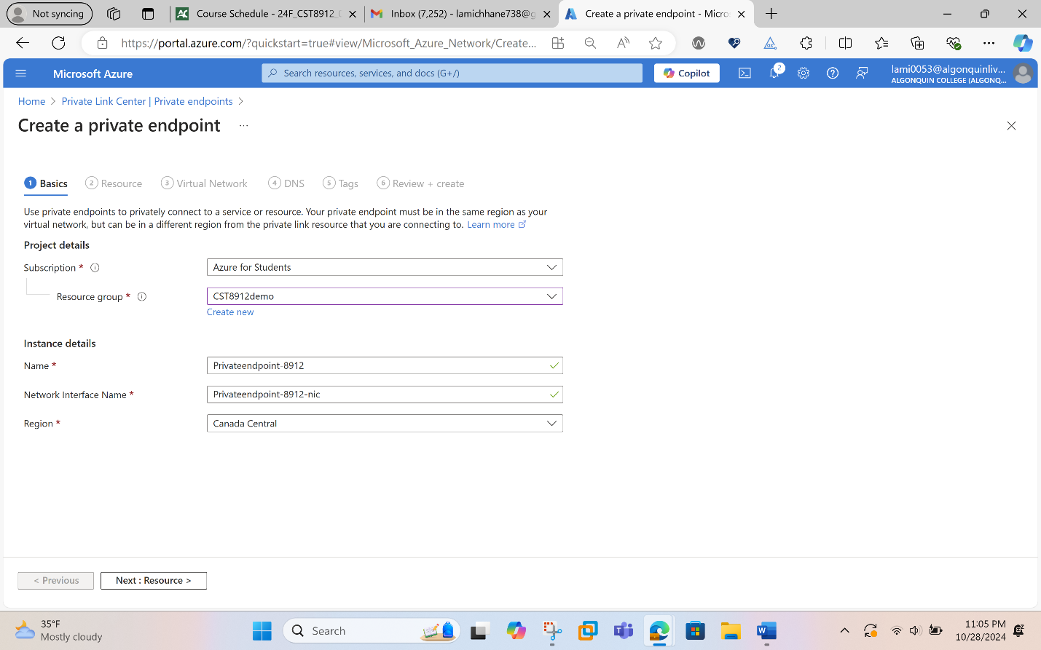
Select Next:Resource
- In the Resource pane, enter or select the following information.
Setting | Value
Connection method | Leave the default of Connect to an Azure resource in my directory.
Subscription | Select your subscription.
Resource type | Select Microsoft.Storage/storageAccounts.
Resource | Select Storage1-8912 or your storage account.
Target subresource | Select blob.

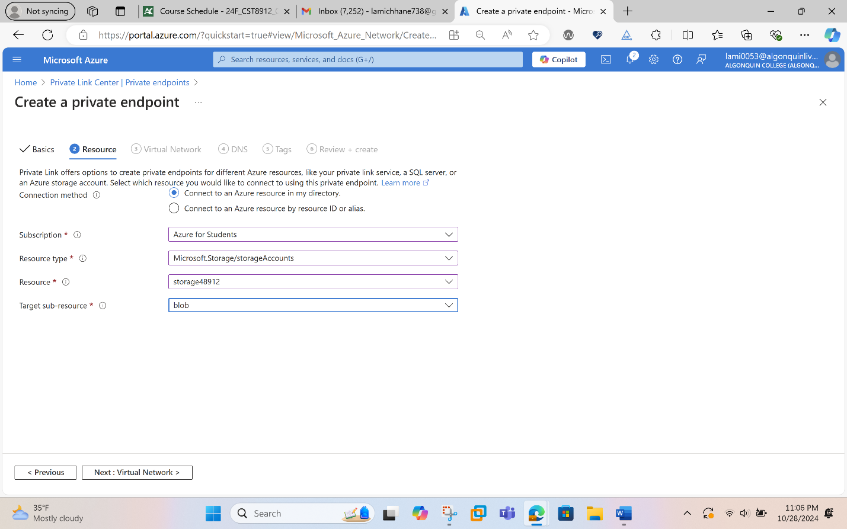
- Select Next: Virtual Network. In Virtual Network, enter or select the following information.
Setting | Value
Virtual network | Select 8912-vnet (CST8912demo).
Subnet | Select Subnet-1-8912.
Network policy for private endpoints | Select edit to apply Network policy for private endpoints.  In Edit subnet network policy, select the checkbox next to Network security groups and Route Tables in the Network policies setting for all private endpoints in this subnet pull-down.  Select Save.
Private IP configuration | Select Dynamically allocate IP address.

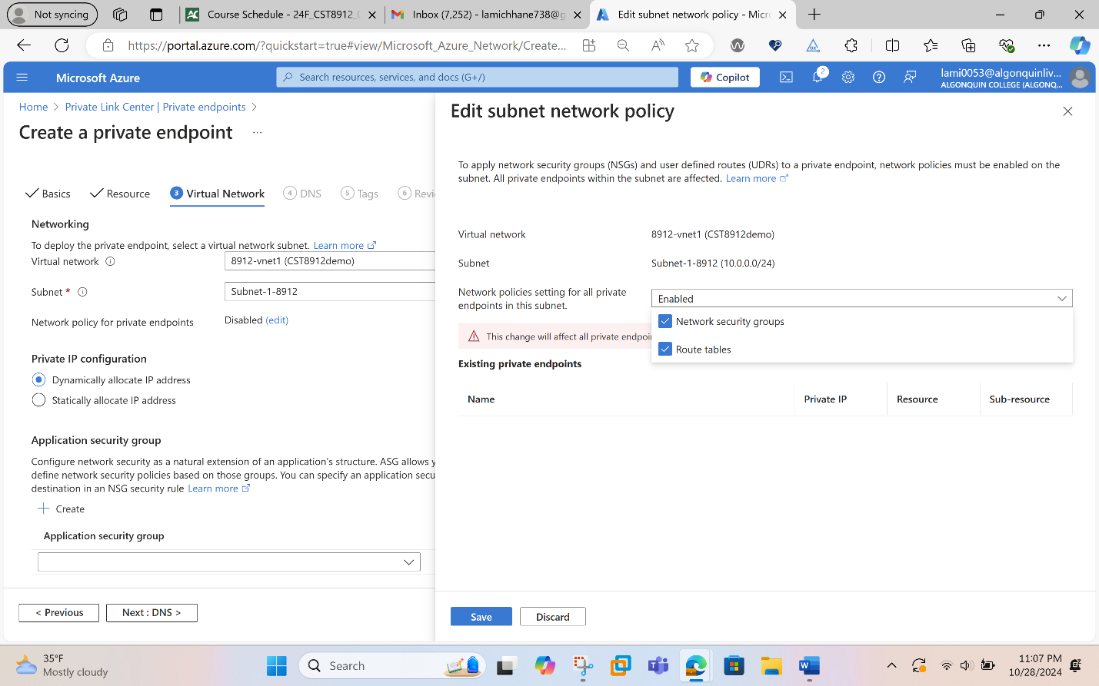
- Select Next: DNS.
- 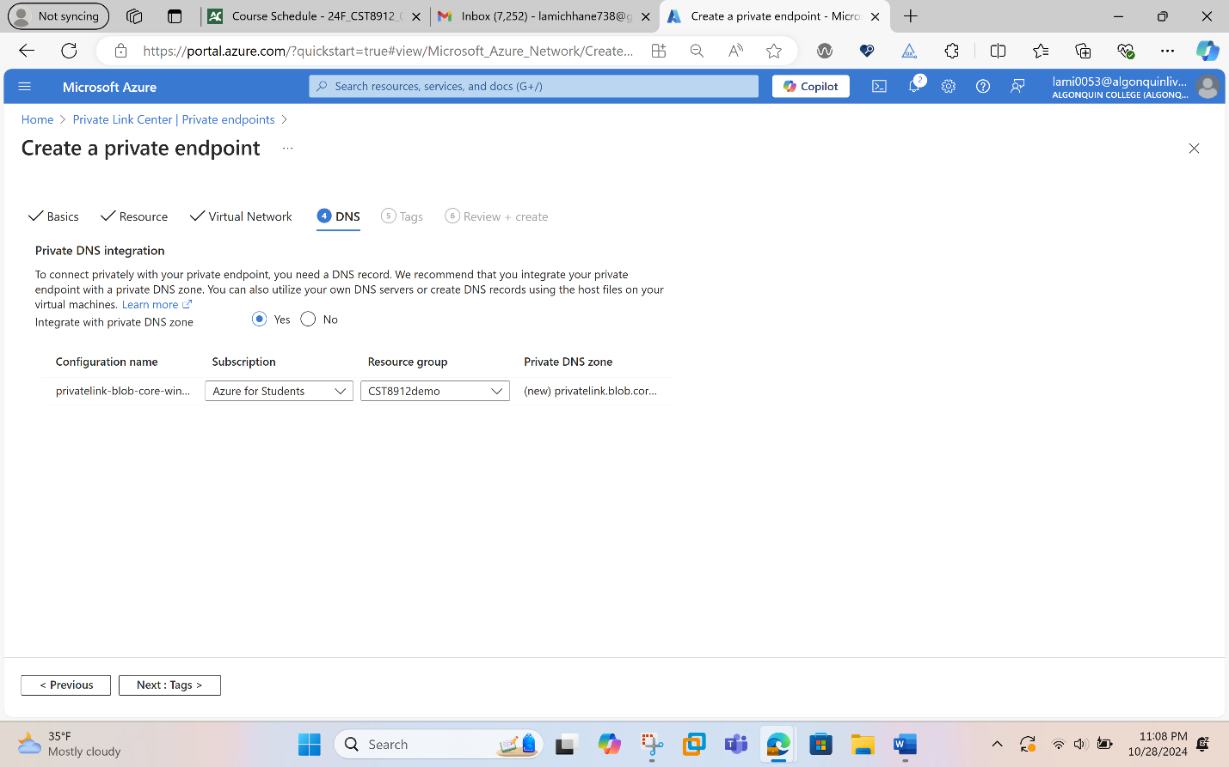
- Leave the defaults in DNS. Select Next: Tags, then Next: Review + create.
- Select Create.
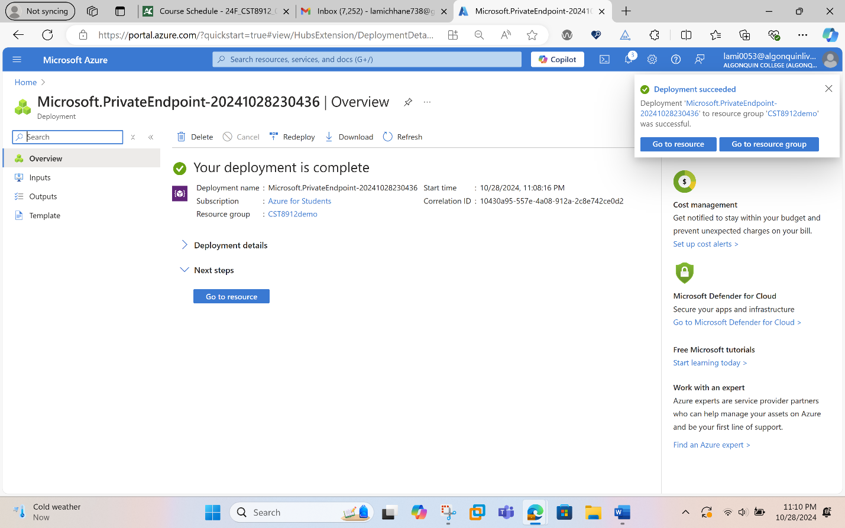
Step 5: Create test virtual machine
In the portal, search for and select Virtual machines. In Virtual machines, select + Create, then Azure virtual machine. On the Basics tab of Create a virtual machine, enter or select the following information:
Setting | Value
Subscription | Azure for students
Resource Group | CST8912demo
Virtual Machine name | 8912-VM1
Region | Canada central
Availability options | No infrastructure redundancy required
Security type | Standard
Image | Select Windows Server 2022 Datacenter - x64 Gen2.
VM architecture | Leave the default of x64.
Size | Select size (B1)
Authentication | Choose username and password
Public inbound ports | Select None

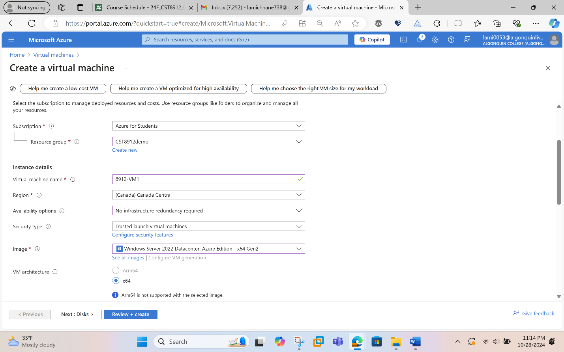
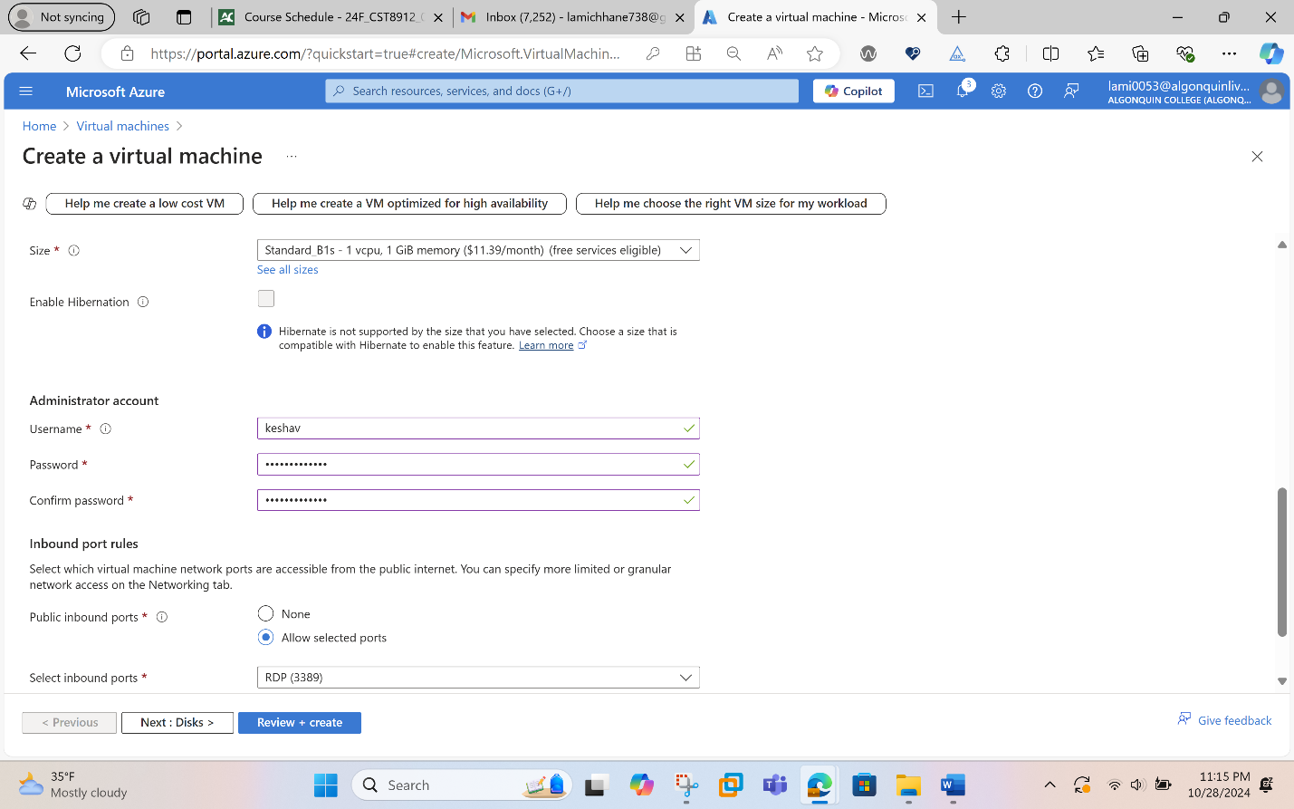
Select the Networking tab at the top of the page. Enter the following information in the Networking tab:
Setting | Value
Virtual Network | Select 8912-vnet (CST8912demo).
Subnet | Select Subnet-1-8912.
Public IP | Select None
NIC network security group | Select Advanced
Configure network security group | Select Create new.  Name it as ‘nsg-1’ for the name.  Leave the rest at the defaults and select OK.

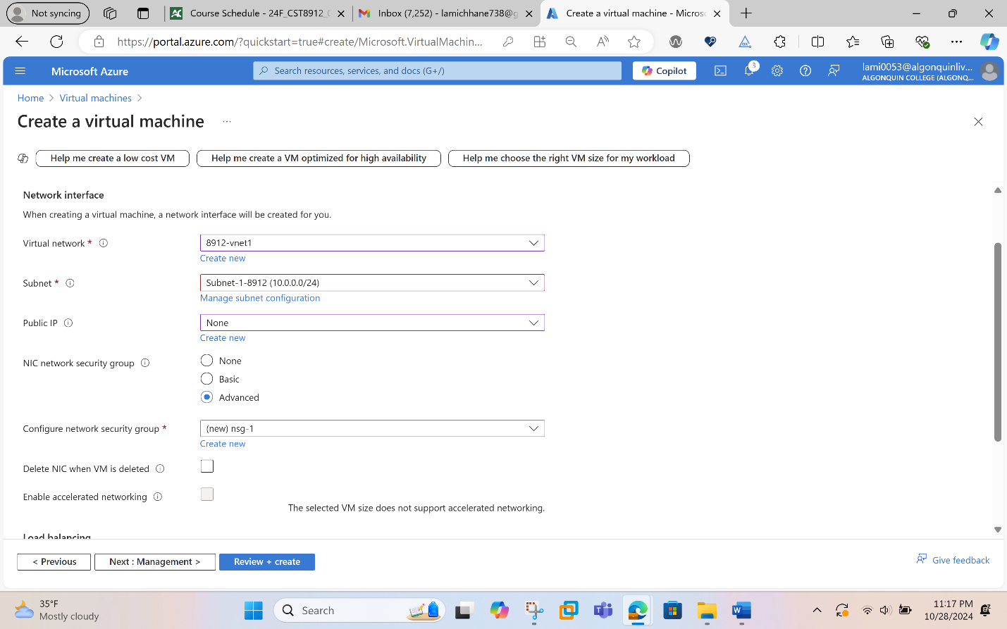
Now we will create a network security group.
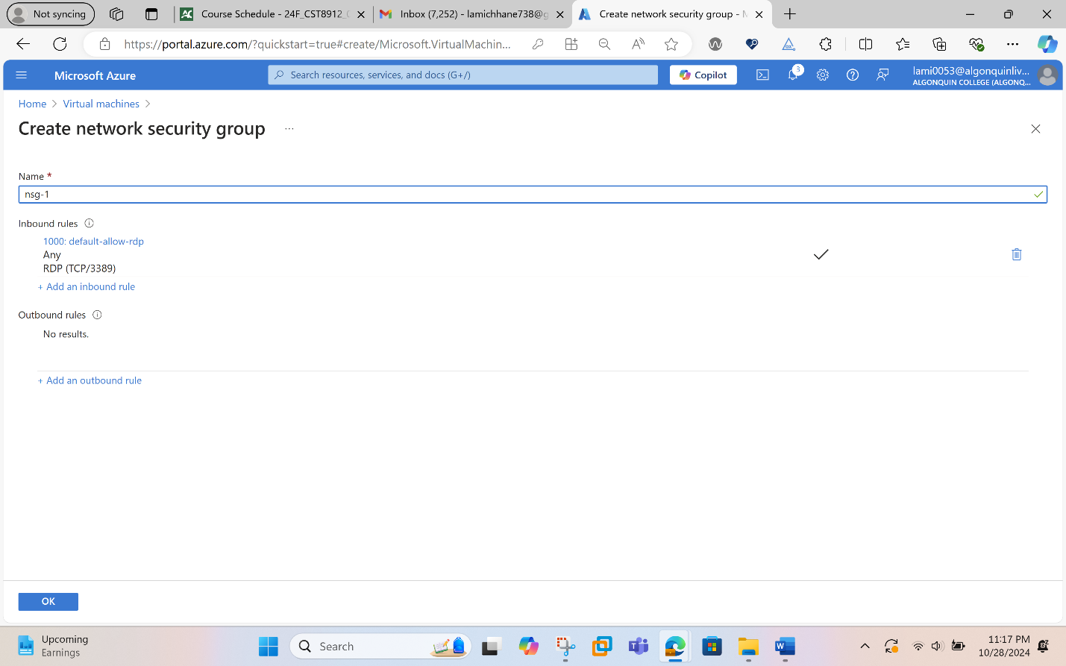

Leave the rest of the settings at the defaults and select Review + create. Review the settings and select Create.
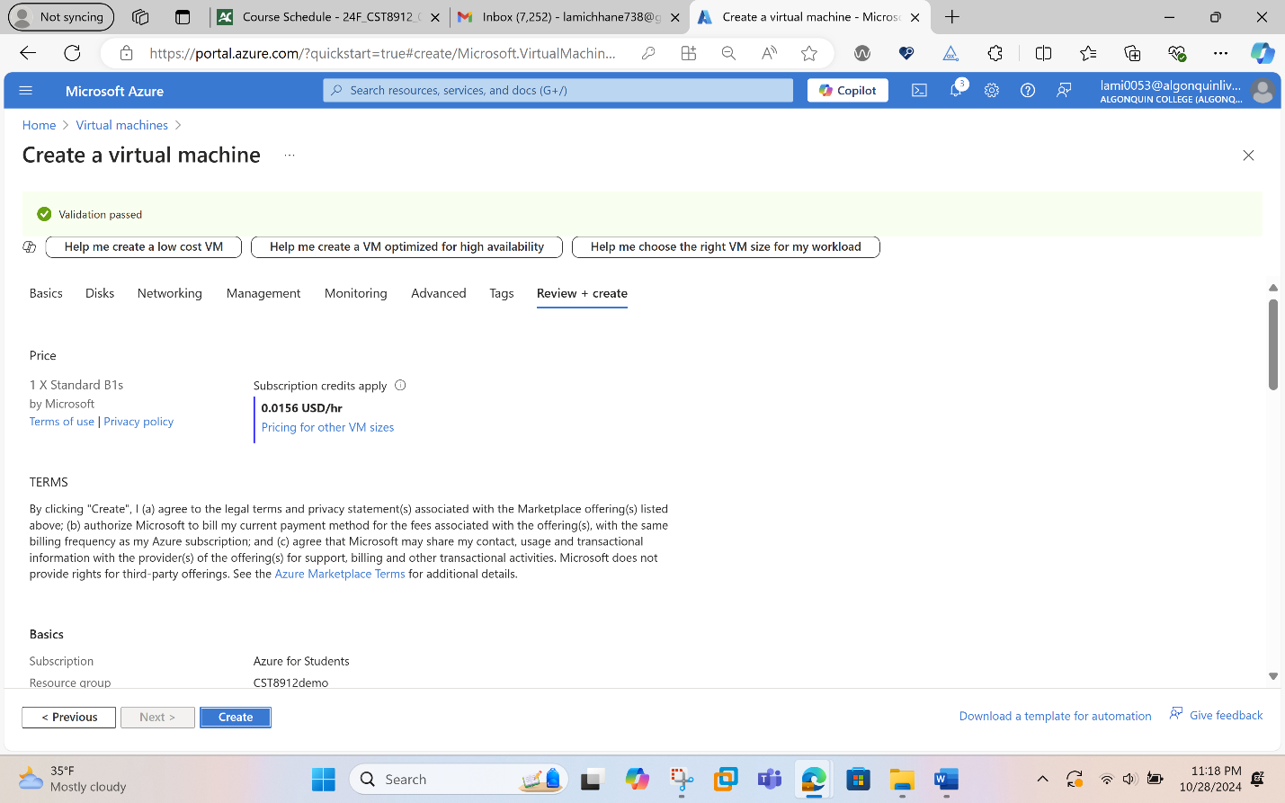

Step 6: Storage access key
In the search box at the top of the portal, enter Storage account. Select Storage accounts in the search results. The select the storage account we created in the previous steps or your existing storage account.
In the Security + networking section of the storage account, we select Access keys. And then we select Show, then select copy on the Connection string for key1.

Note: In this step copy the connection string, not the key.

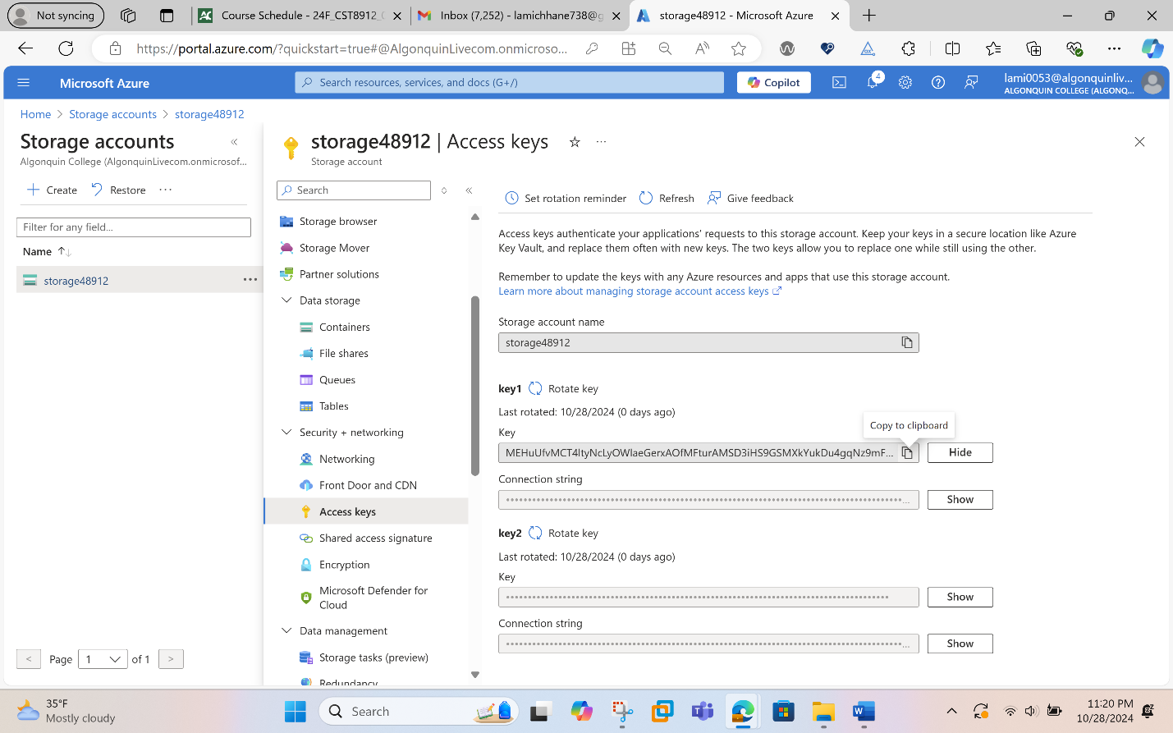

Step 7 :Add a blob container

In the search box at the top of the portal, enter Storage account. Select Storage accounts in the search results. Select the storage account you created in the previous steps. In the Data storage section, select Containers. Select + Container to create a new container. Enter the container in Name and select Private (no anonymous access) under Public access level and finally select Create.

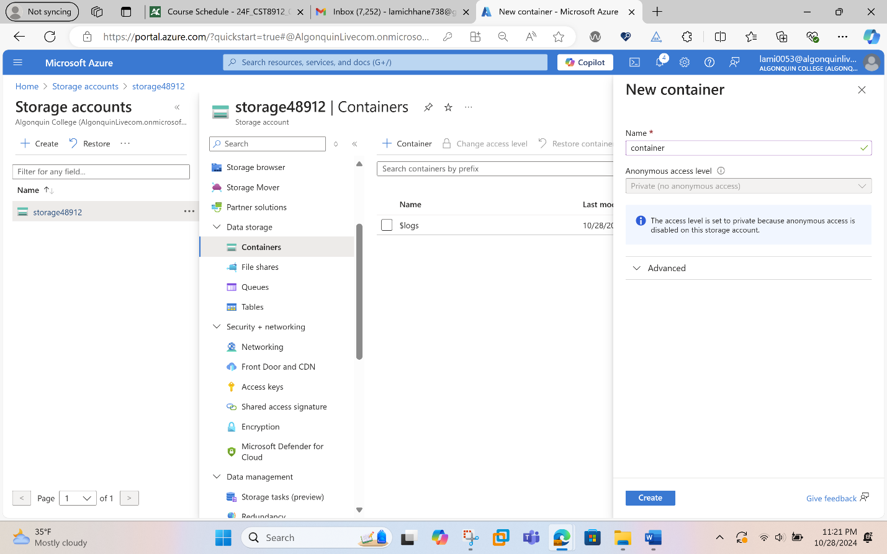

The created container is shown below:

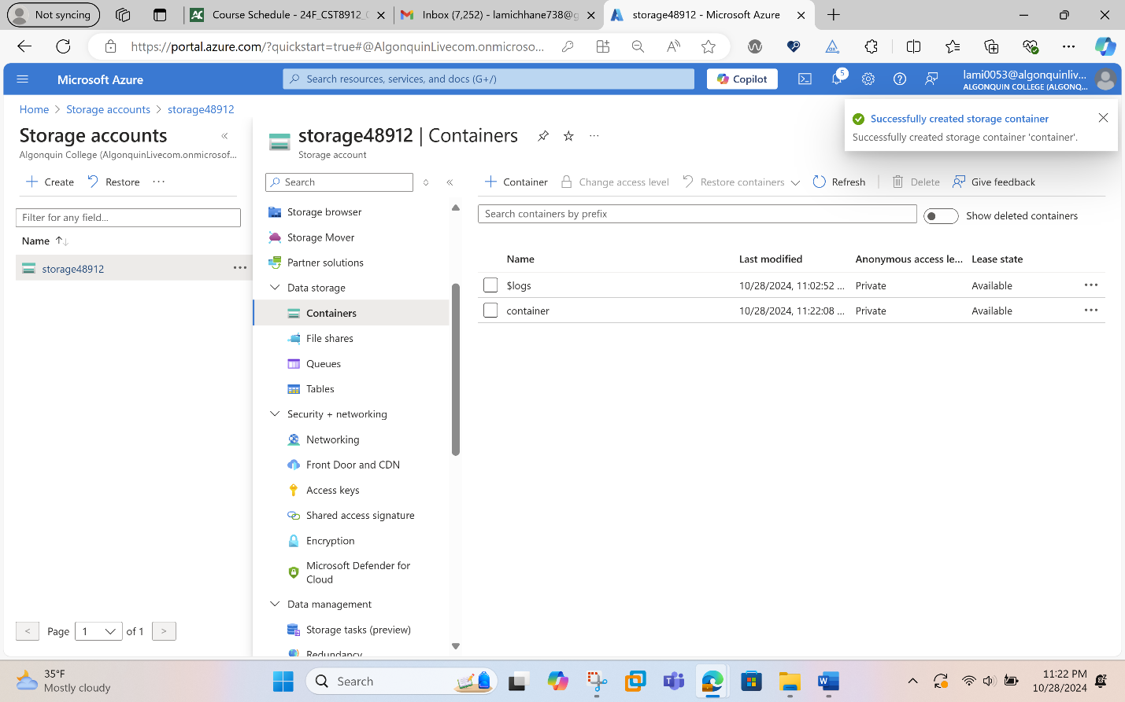

Step 8: Test connectivity to private endpoint
In the search box at the top of the portal, enter Virtual machine. Select Virtual machines in the search results.
- Select 8912-VM1.
- In Operations, select Bastion.
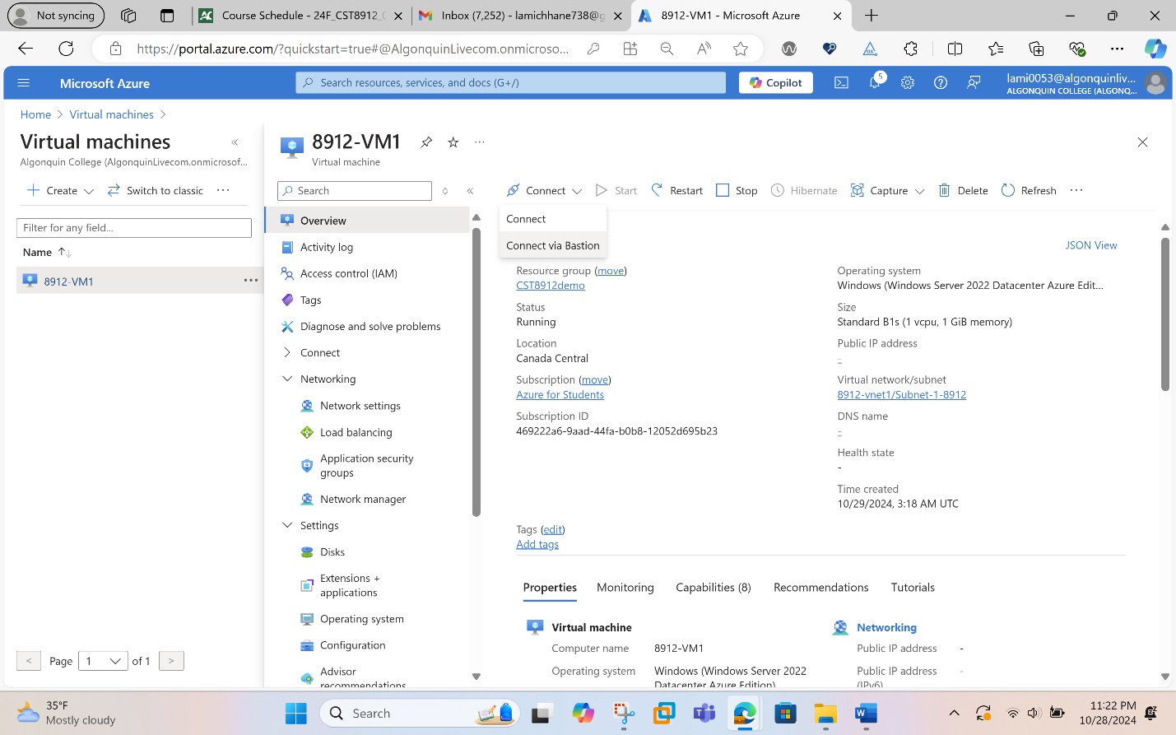
- Enter the username and password that we entered during the virtual machine creation.
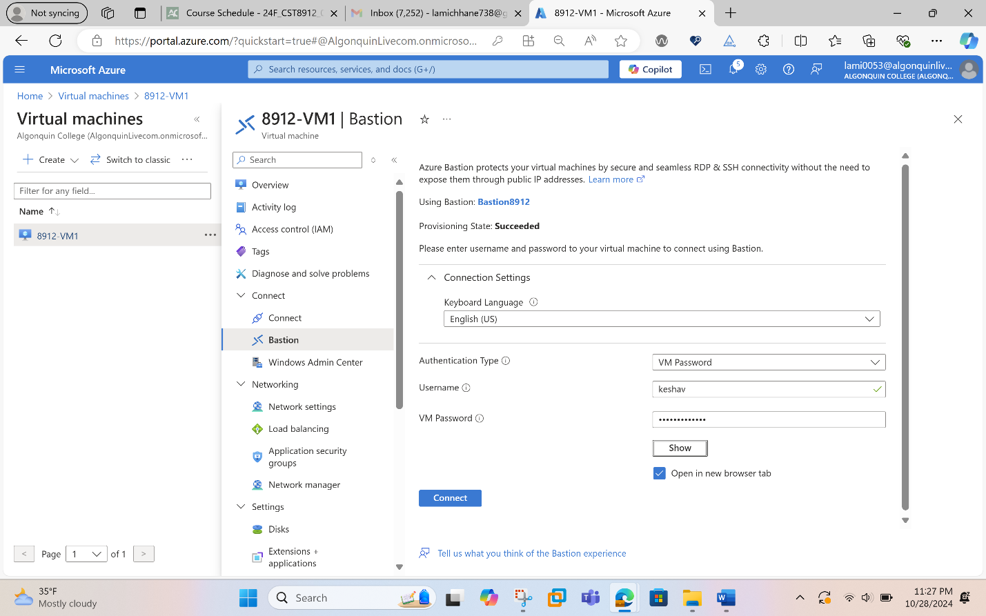
- Select Connect.
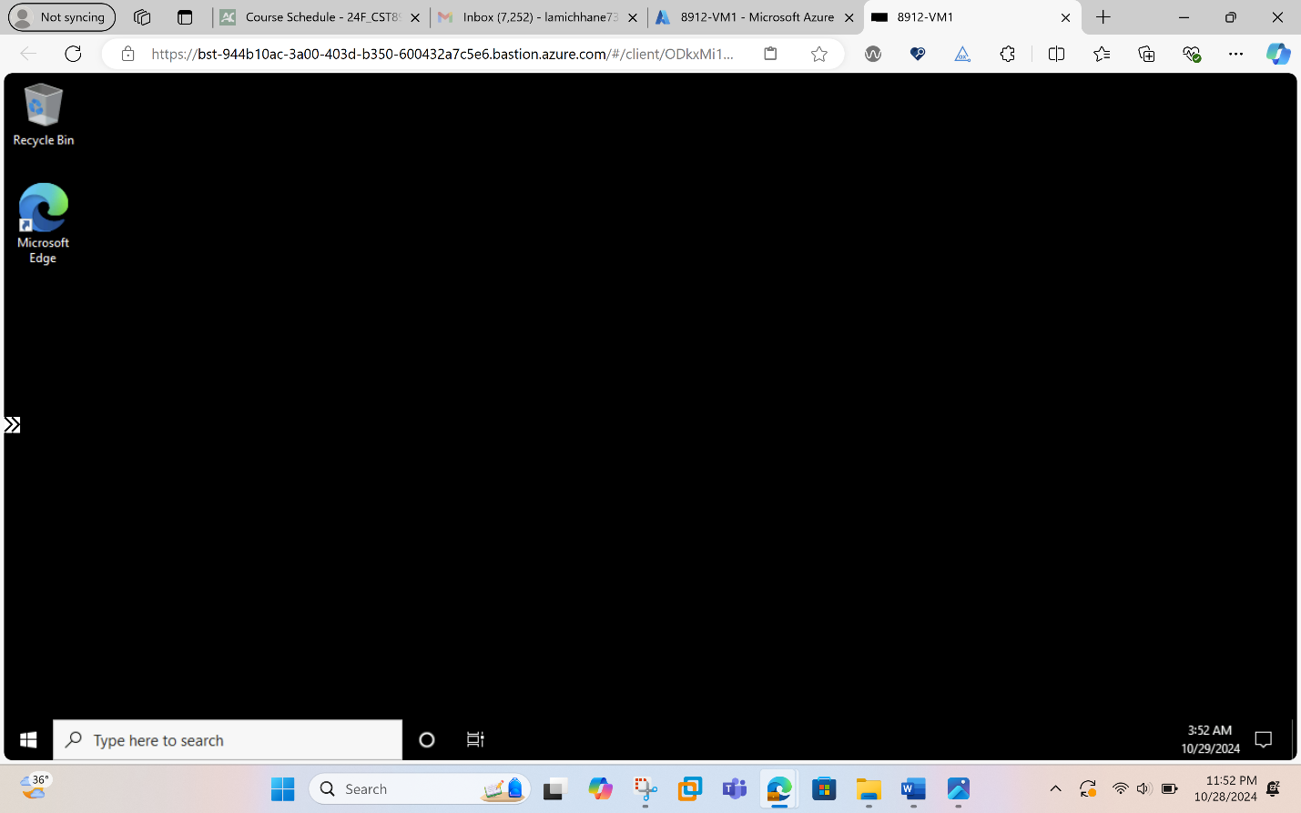
- Open Windows PowerShell on the server after you connect.
- Enter nslookup <storage-account-name>.blob.core.windows.net. Replace <storage-account-name> with the name of the storage account we created in the previous steps.
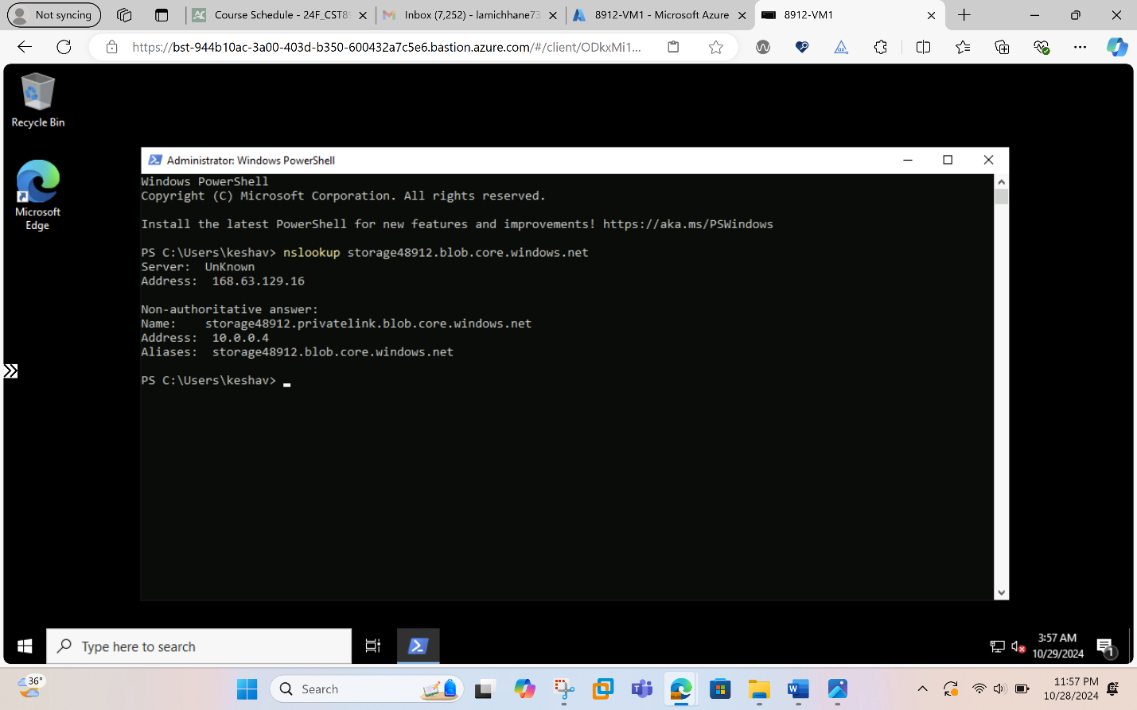
- Install Microsoft Azure Storage Explorer on the virtual machine.
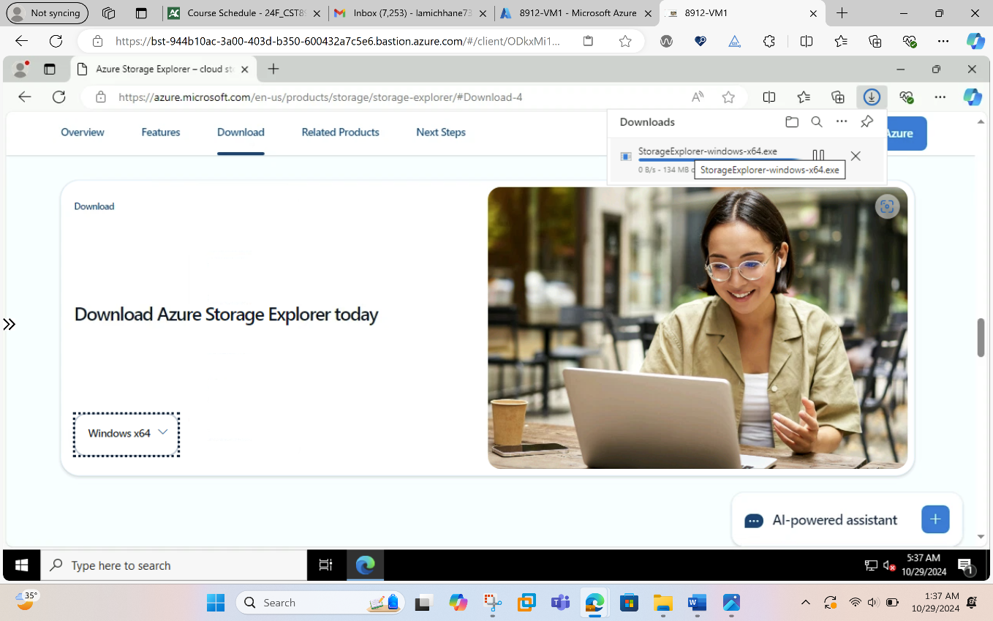
- Select Finish after the Microsoft Azure Storage Explorer is installed. Leave the box checked to open the application.
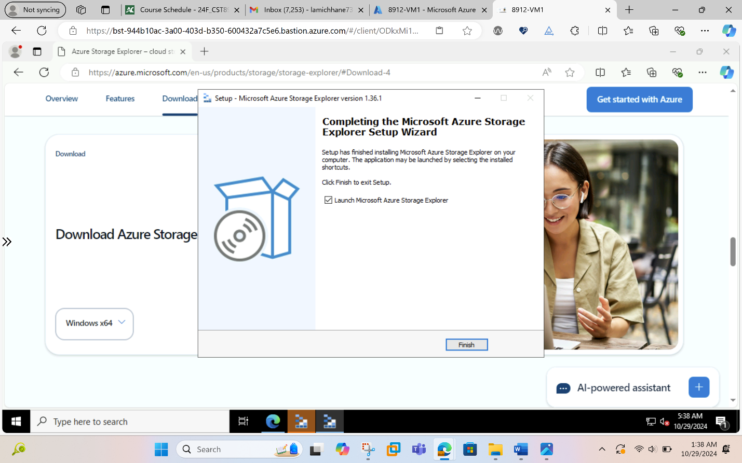
- Select the Power plug symbol to open the Select Resource dialog box in the left-hand toolbar.
- In Select Resource , select Storage account or service to add a connection in Microsoft Azure Storage Explorer to our storage account that we created in the previous steps.
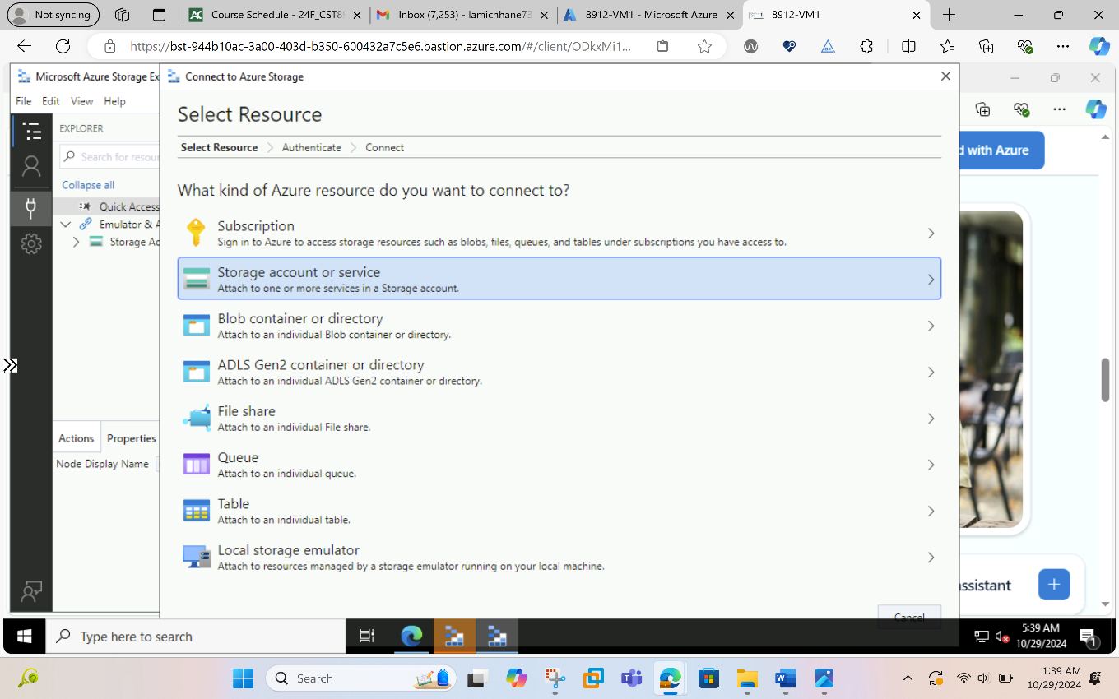
- In the Select Connection Method screen, select Connection string, and then Next.
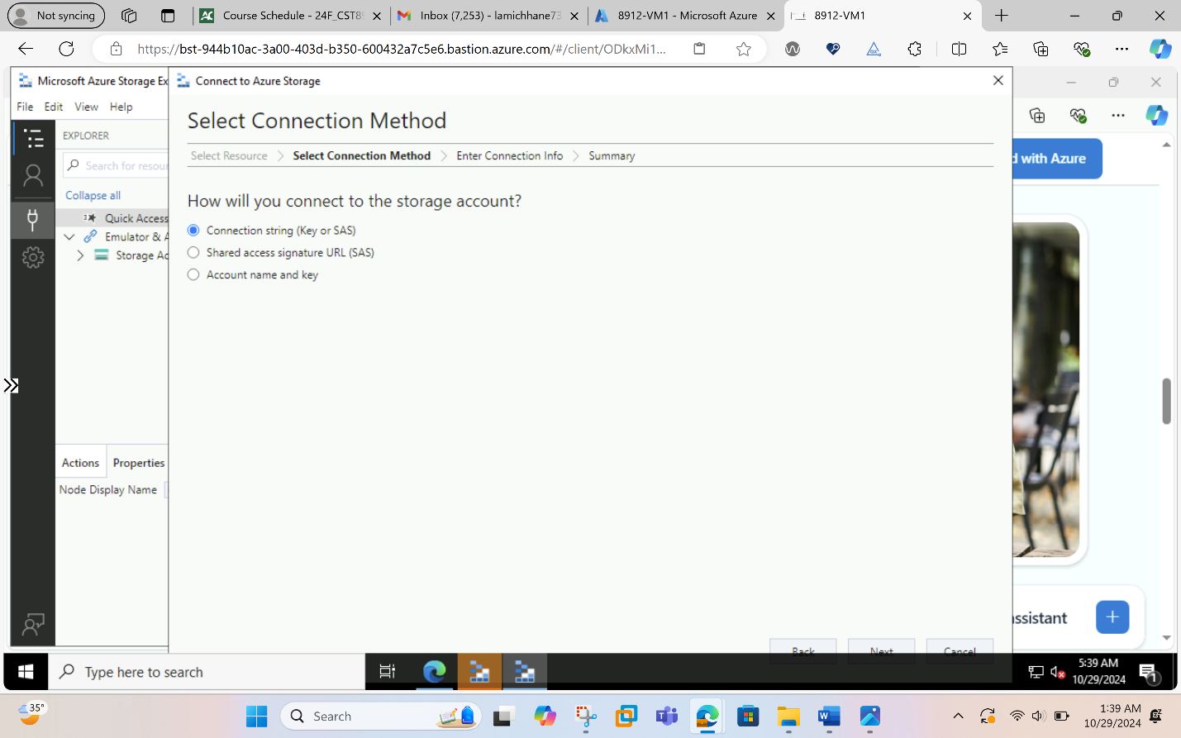
- In the box under Connection String, paste the connection string from the storage account we copied in the previous steps. The storage account name automatically populates in the box under Display name.
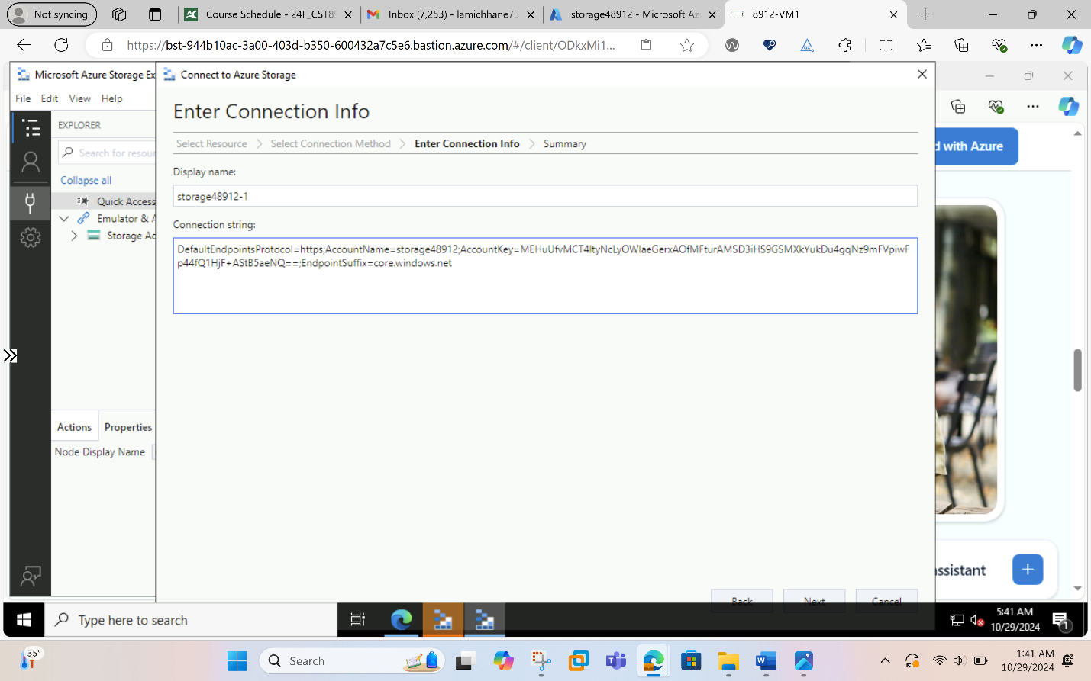
- Select Next.
- Verify the settings are correct in Summary.
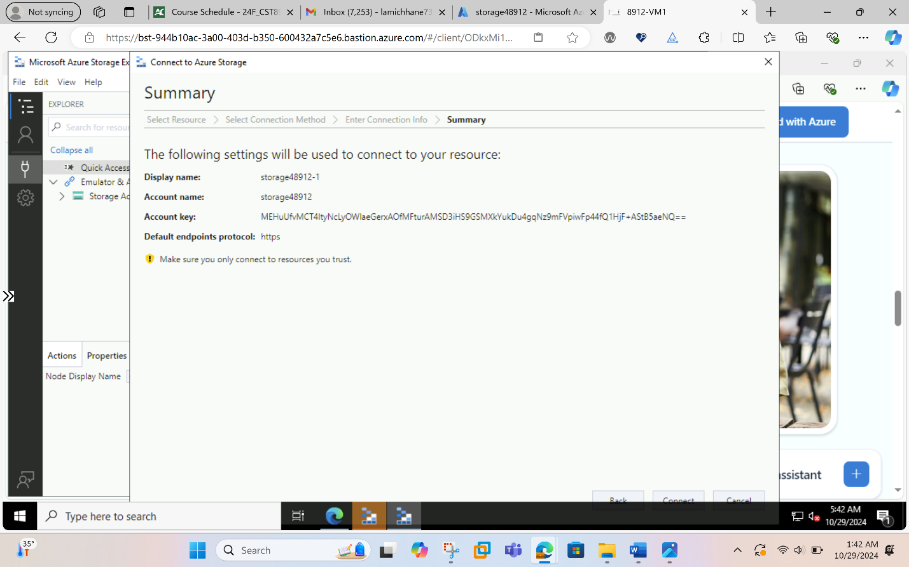
- Select Connect
- Select the storage account from the Storage Accounts in the explorer menu.
- Expand the storage account and then Blob Containers.
- The container that wre created previously is displayed.
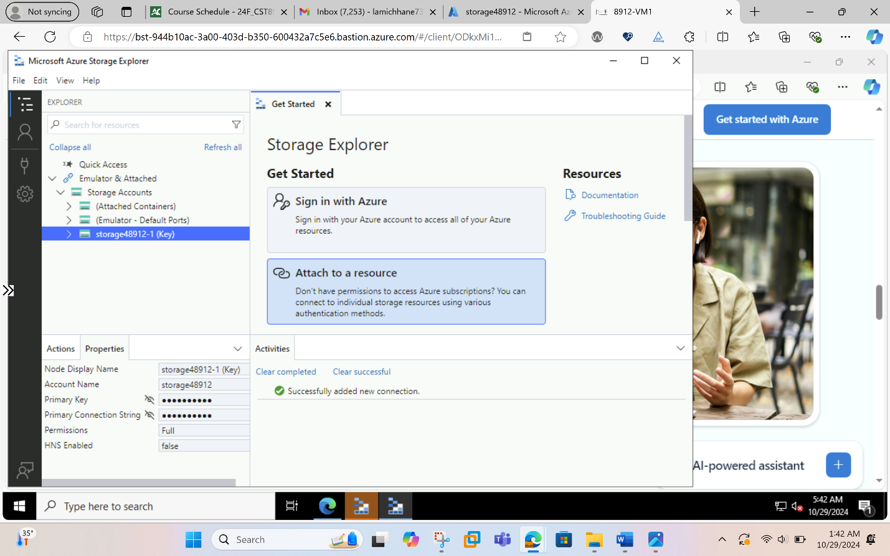
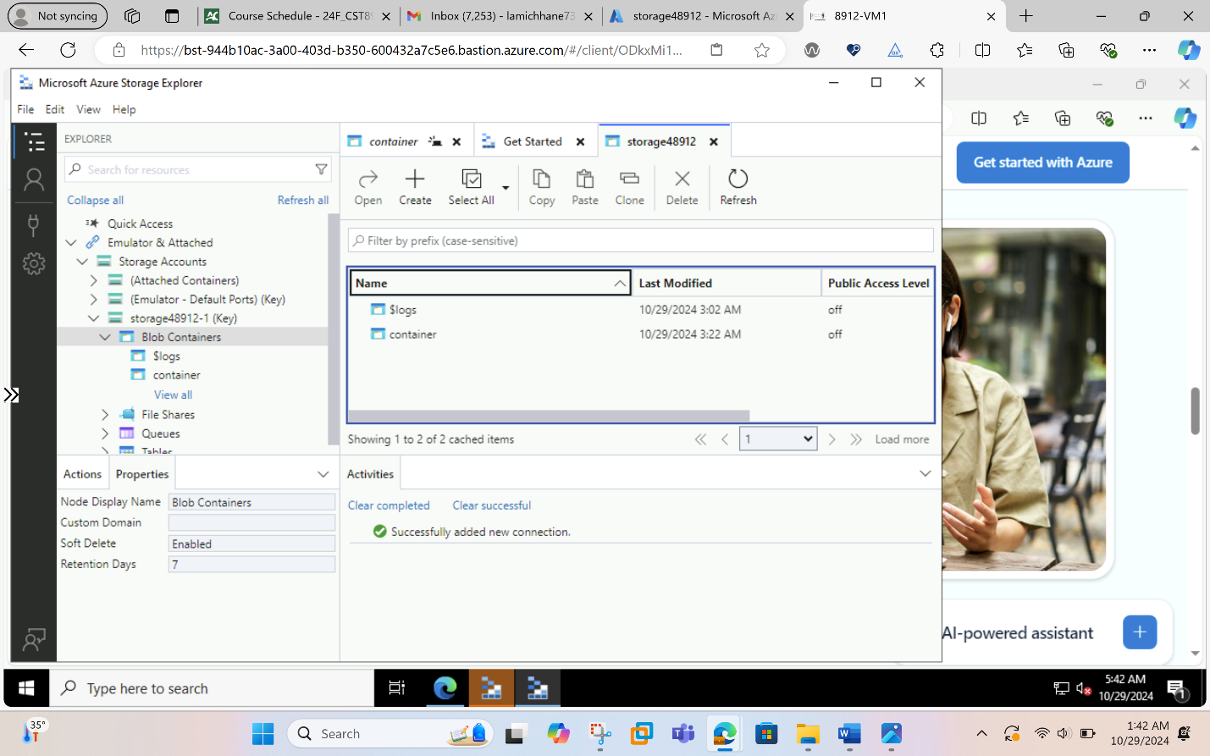
- Close the connection to 8912-VM1.
- Clean all the resources created during the lab .
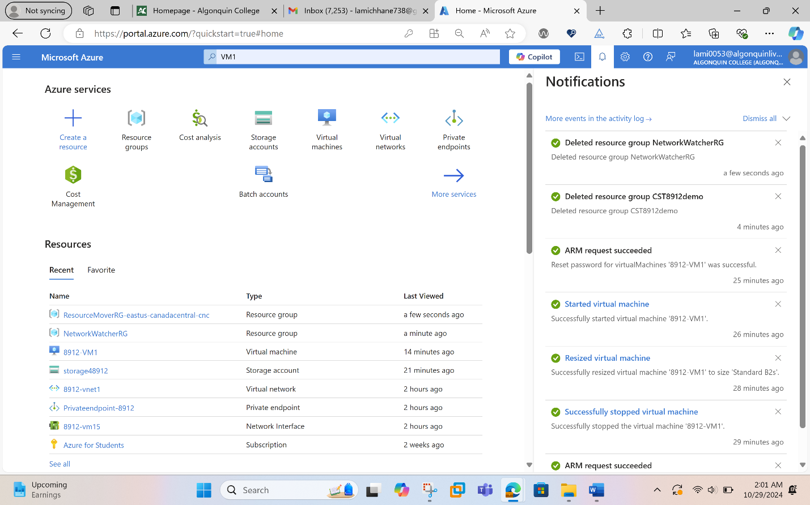
This final screenshot ensures that all the resources created for this lab were deleted successfully as per the requirement of lab instruction.

Conclusion:
In this lab, we successfully set up Azure Private Link and Private Endpoint, guaranteeing private and secure access to Azure services over a virtual network. This exercise taught us how to join Azure resources securely without exposing data to the public internet by configuring a private endpoint, turning off public access, and testing connectivity. This configuration provides a strong basis for a secure network design in Azure by improving data privacy, satisfying compliance requirements, and lowering the risks related to internet exposure.

